EXP:5 | Cloud Backup and Migration using Google Drive
14/8/2026 | Cloud Backup and Migration using Google Drive
AIM
To create a cloud backup system by storing important files in Google Drive, scheduling automatic backups, and verifying successful backup completion.

REQUIREMENTS
- Windows 10/11
- Google Account
- Internet Connection

THEORY
Cloud Backup means storing a copy of important files on cloud servers instead of keeping them only on the local computer. Cloud Migration means moving files, applications, or data from a local computer to a cloud service.
In this experiment, the local OfficeData folder is migrated to Google Drive and Google Drive for Desktop is configured to synchronize the local folder. A change to Student.txt is then used to verify automatic backup.

PROCEDURE

1.Create Sample Data
- Create a folder named OfficeData on the Desktop/local working directory.
- Inside OfficeData, create three text files: Student.txt, Attendance.txt and Marks.txt.
- Enter sample content in the files.
Sample content used:
- Student.txt – Name : Student; Department : AI & DS
- Attendance.txt – Attendance : 95%
- Marks.txt – Cloud Computing : 98
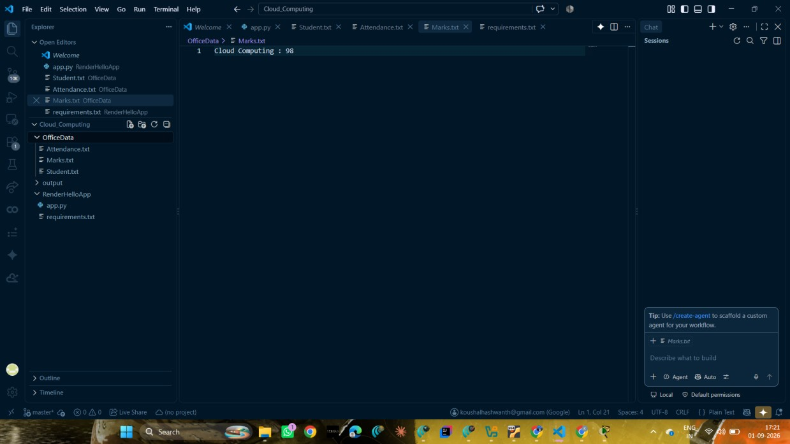
Fig. 1 – Sample OfficeData folder containing Student.txt, Attendance.txt and Marks.txt.

2.Create Cloud Storage
- Open Google Drive in a web browser and sign in with the Google account.
- Click + New → Folder.
- Create a folder named CloudBackup.
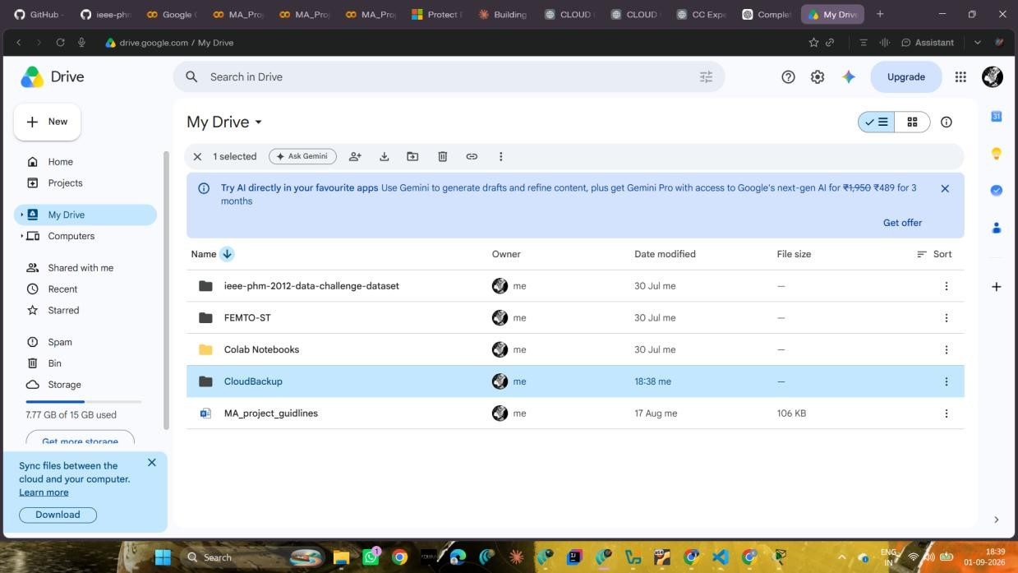
Fig. 2 – CloudBackup folder created in Google Drive.

3.Upload Files
- Open the CloudBackup folder.
- Upload the OfficeData folder/files from the local computer.
- Wait until the upload is complete.
The upload confirmation showed that all 3 of 3 items were uploaded successfully.
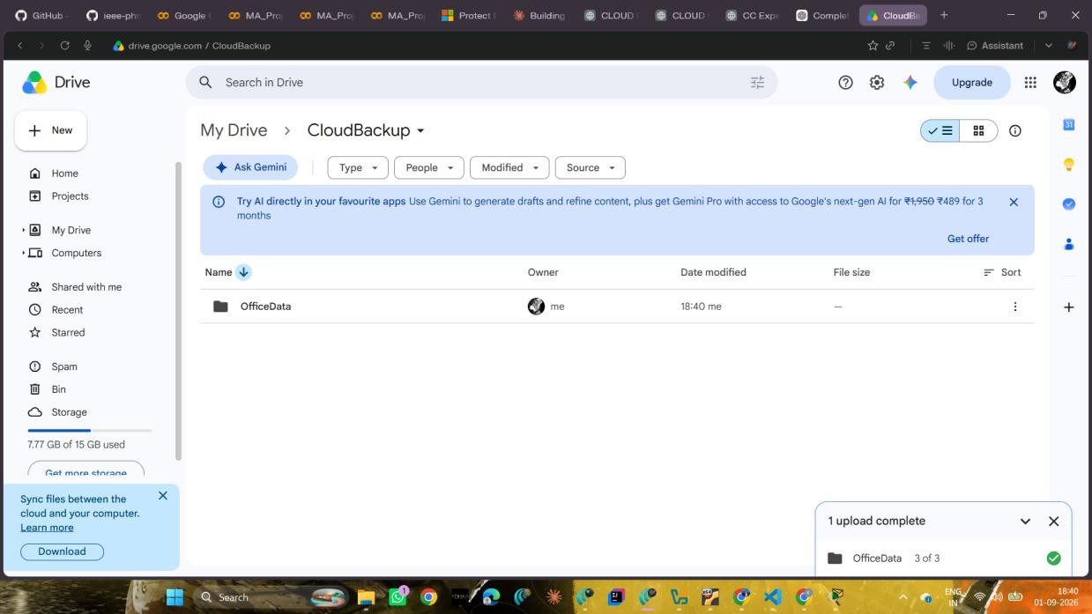
Fig. 3 – OfficeData uploaded successfully to CloudBackup (3 of 3 items).

4.Install Google Drive for Desktop
- Download and install Google Drive for Desktop.
- Sign in using the same Google account used for Google Drive Web.
- Open the Google Drive Desktop application and confirm that it is running.
- Google Drive Desktop was successfully installed and used for the synchronization setup.

5.Enable Folder Synchronization
- Open Google Drive Preferences.
- Under folders from the computer, add/select the OfficeData folder.
- Enable synchronization with Google Drive and complete the setup.
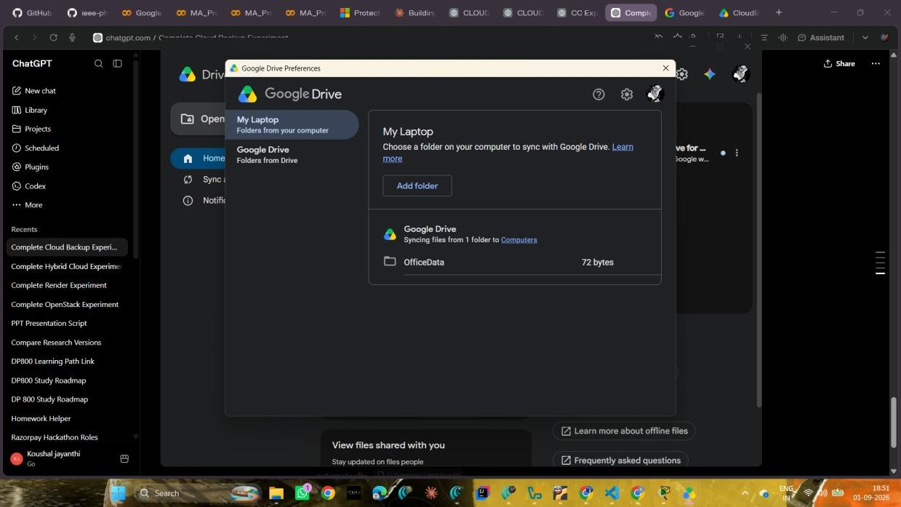
Fig. 4 – Google Drive Preferences showing OfficeData configured for synchronization.

6.Test Automatic Backup
- Open the local OfficeData folder and open Student.txt.
- Add the following line at the bottom of the file:
Cloud Backup Test - Successfully Synchronized
- Save Student.txt.
- Wait approximately 10–30 seconds for synchronization.
- Open Google Drive Desktop and verify that the status becomes Up to date / Successfully uploaded.
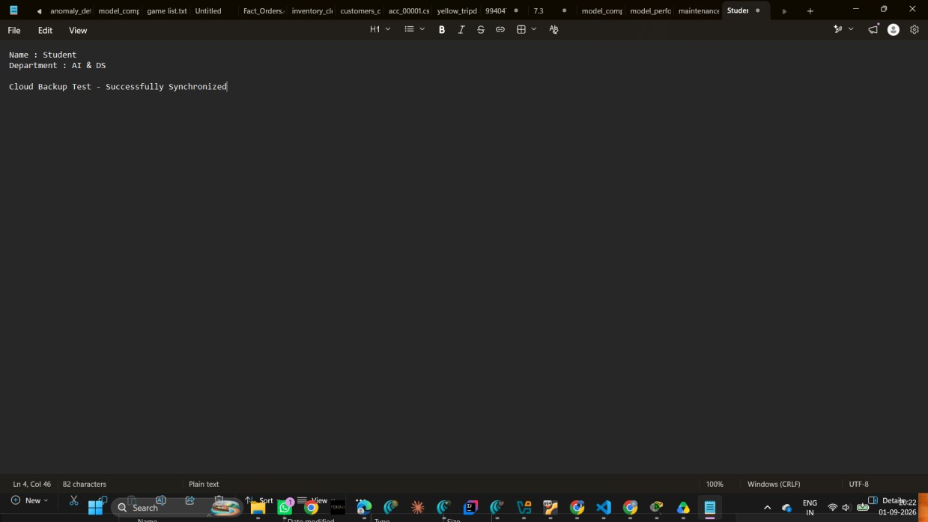
Fig. 5 – Student.txt modified with the cloud backup synchronization test line.
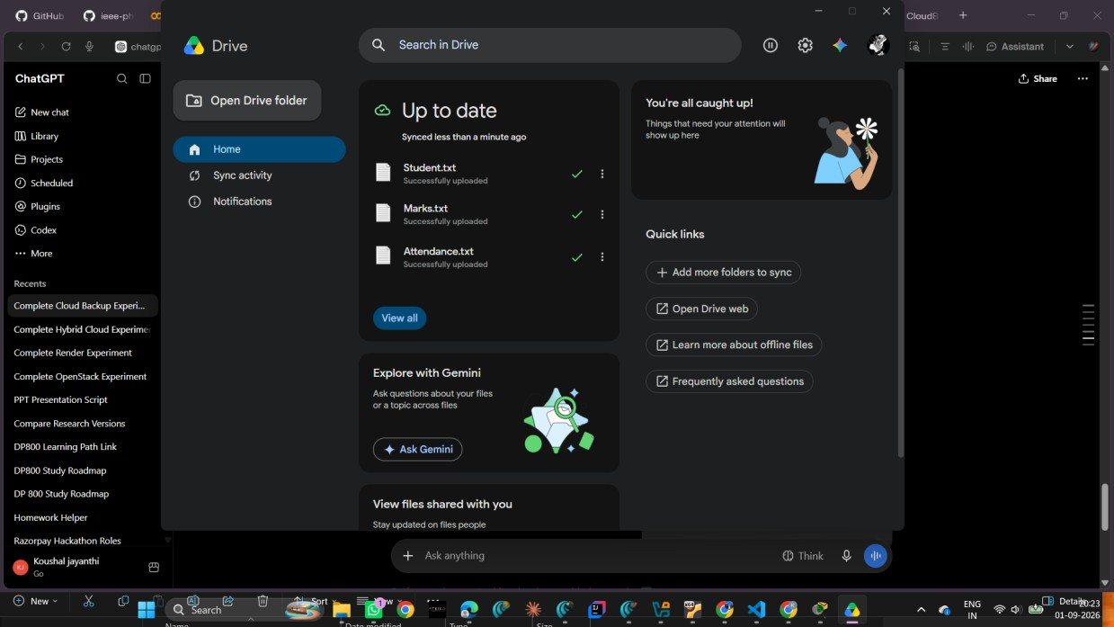
Fig. 6 – Google Drive Desktop showing Up to date and successfully uploaded files.

OUTPUT / RESULT
The local Student.txt file was modified with the synchronization test message. Google Drive Desktop reported the file as successfully uploaded and the overall sync status as Up to date.
The final Google Drive Web verification showed the same synchronization test message in Student.txt, confirming that the local change was reflected in cloud storage.
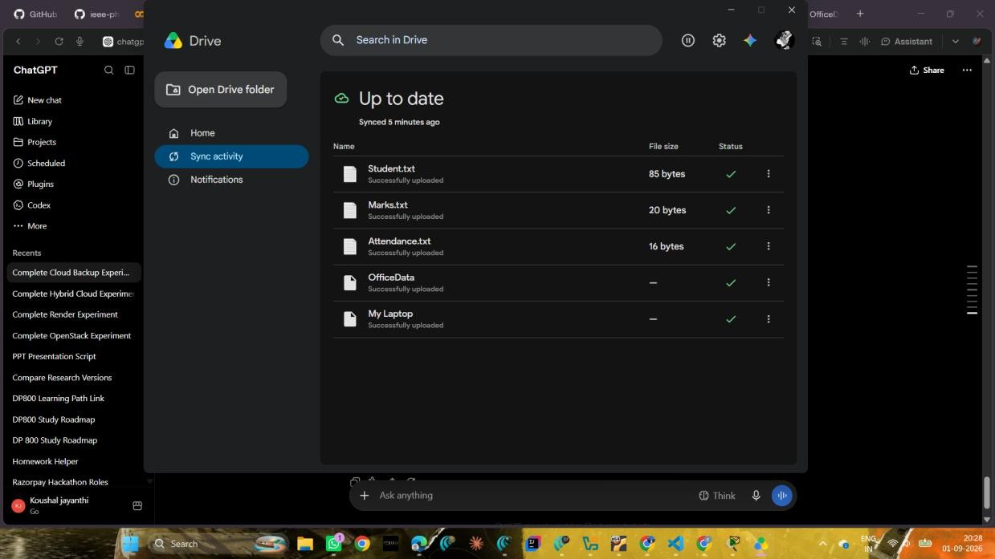
Fig. 7 – Google Drive Web verification showing the synchronized Student.txt content.

OBSERVATION / VERIFICATION
Test / Observation | Expected | Observed
OfficeData creation | 3 sample text files | Completed
CloudBackup creation | Folder in Google Drive | Completed
File migration | 3 items uploaded | 3 of 3 uploaded
Synchronization setup | OfficeData synced | Configured
Automatic backup test | Updated file uploaded | Successfully uploaded
Cloud verification | Test line visible online | Verified

CONCLUSION
The cloud backup setup was successfully completed using Google Drive. Local files were migrated to cloud storage, automatic synchronization was enabled, and updates to local files were successfully reflected in the cloud, demonstrating an effective cloud backup mechanism.

CS23633 | 7 | 231801014

